Steps To Uninstall Oracle 12.1.0.1 & 11.2.0.1 On Windows
- Log into to your windows machine as the oracle user (if you have created a new account for the oracle user or as the user who installed oracle. Be sure you have administrative privileges on this account.
- Stop all the Oracle services related to the ORACLE_HOME (if any are running).
- Right click on the start menu –> Control Panel –>System and Security
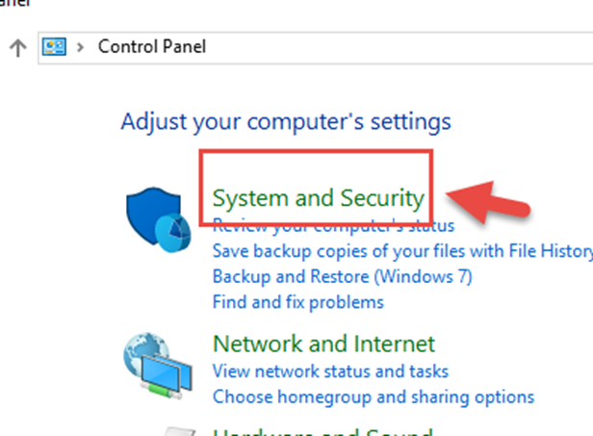
- Click on Administrative Tools
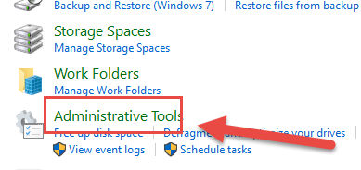
- Click on Services
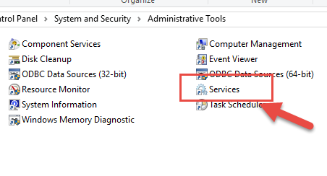
- Find all the oracle services running from your ORACLE_HOME. Select them one at a time and click on Stop the service
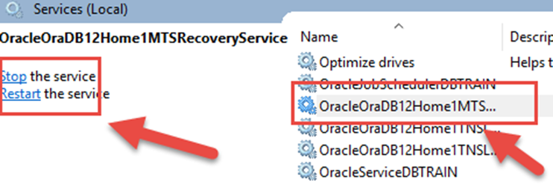
- Check the status to verify that all the services have been stopped.
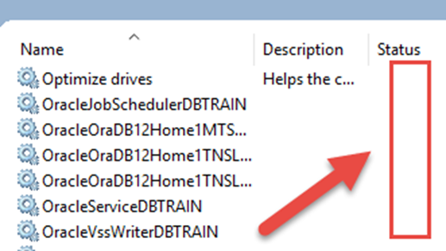
- Invoke the deinstall tool. It is located in a similar location on your windows machine: C:\app\oracle\product\12.1.0\dbhome_2\deinstall (C:\app\oracle\product\11.2.0\dbhome_2\deinstall)
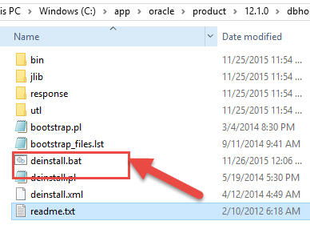
- Right click on the start menu and select the Command Prompt
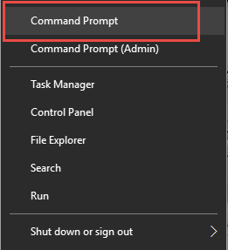
- This launches the Command prompt
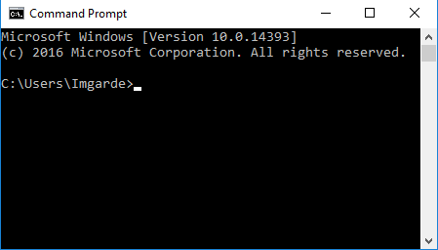
- As you can see, the current directory is C:\Users\Imgard. But you have to navigate to the C:\app\oracle\product\12.1.0\dbhome_2\deinstall directory to invoke the deinstall tool.
In your case, it will be from the 11gR2 home (C:\app\oracle\product\11.2.0\dbhome_2\deinstall).
You use the cd command (Change directory) to move from one directory to another on the command line.
So type cd C:\app\oracle\product\12.1.0\dbhome_2\deinstall and hit enter on your keyboard.
Once you have verified that you are in the C:\app\oracle\product\12.1.0\dbhome_2\deinstall directory. Type deinstall to call the deinstall tool.
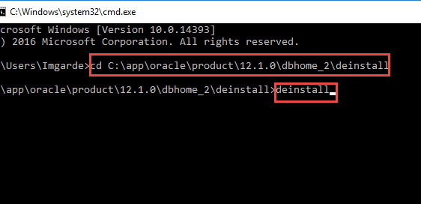
- As you can see, the de-installation process is running which will start removing your oracle files from your machine.
The deinstall tool stops Oracle software, and removes Oracle software and it's components, like database and configuration files, listener.
The deinstall tool is designed in a way which executes a lot of checks before deleting all the directories under ORACLE_HOME (see the log file attached with this document) and finally ORACLE_BASE on your machine for a specific Oracle Home.
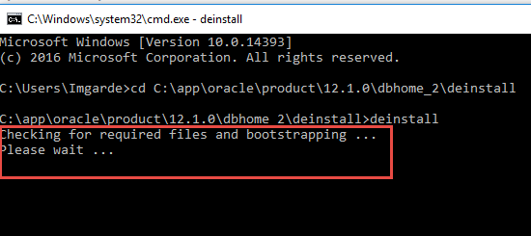
- Remove entries in the registry.
Exercise extreme caution when removing registry entries! Removing incorrect entries can severely corrupt your computer and may require re-installation of the Windows Operating System
  - Start the registry editor. Right click on Start > Run > regedit.
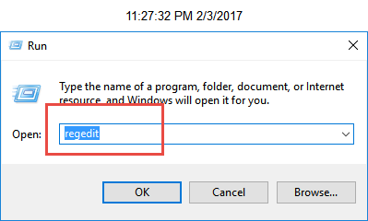
  - Go to HKEY_LOCAL_MACHINE\SOFTWARE\ORACLE\KEY_<ORACLE_HOME> and delete that entry.
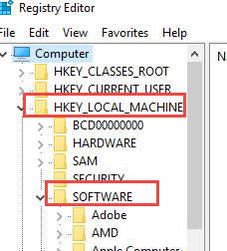
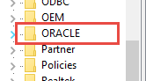
  - Go to HKEY_LOCAL_MACHINE\SOFTWARE\ODBC. Expand all subkeys and remove the key: "Oracle in <ORACLE_HOME>".
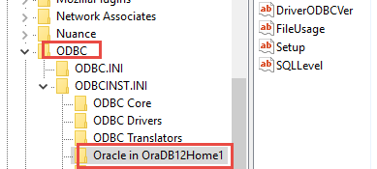

  - Go to HKEY_LOCAL_MACHINE\SYSTEM\CurrentControlSet\Services. Delete any keys with names beginning with Oracle.
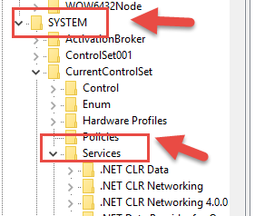
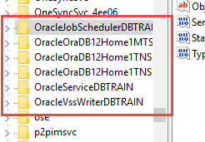

- Clean up the environment settings:
  - Right click on the start menu –> Control Panel –>System and Security –> System –> Advanced system settings to the left –> Advanced tab Environment Variables tab
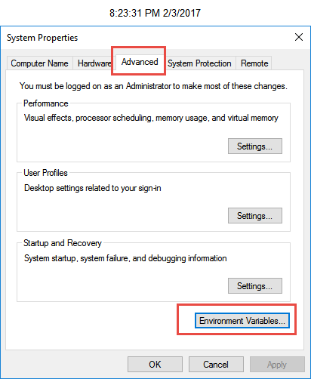
  - Review all variables for any reference to the deleted ORACLE_HOME. Edit by removing the ORACLE_HOME from the string value (such as removing the home from PATH statement) or by deleting the entire variable. Common examples are CLASSPATH, ORACLE_HOME, PATH.
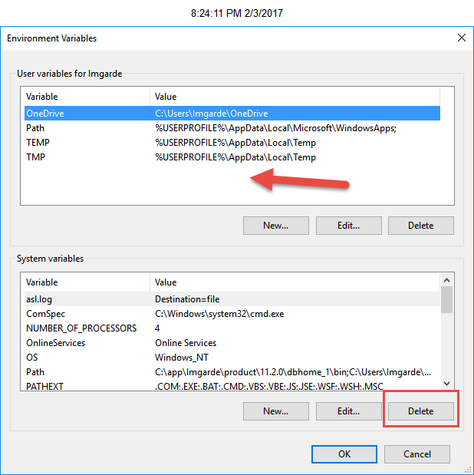
  - Click OK to save and exit System Properties.
- Clean up the start menu icons.
  - Click on the Start button and find the menu icon for the ORACLE_HOME you want to delete and select the drop down menu to see all the components.
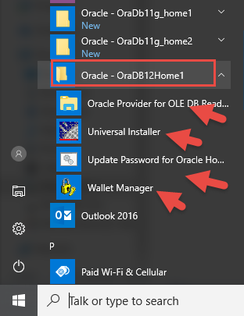
  - Select each component and open the file location.
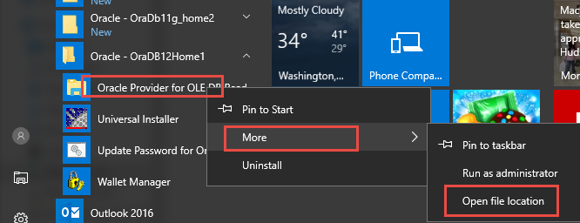
  - Delete the shortcut for each of the oracle components on the menu.
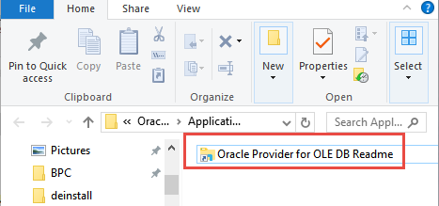
- If this is the only ORACLE_HOME on your machine, delete the Oracle folder under C:\Program Files. DO NOT delete this if there are any other Oracle products on your machine.
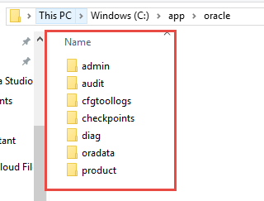
- Go to the ORACLE_HOME location and verify all folders/files have been removed.
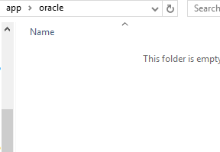

- Go to the C:\TEMP directory and delete all files and directories if any.
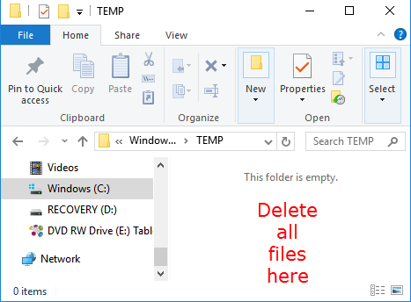

- Empty the Recycle Bin to clear all files.
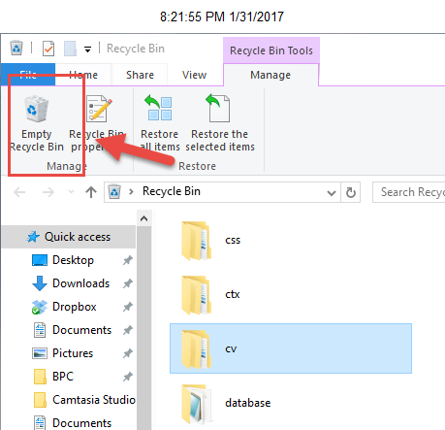
- Reboot your Windows machine.
